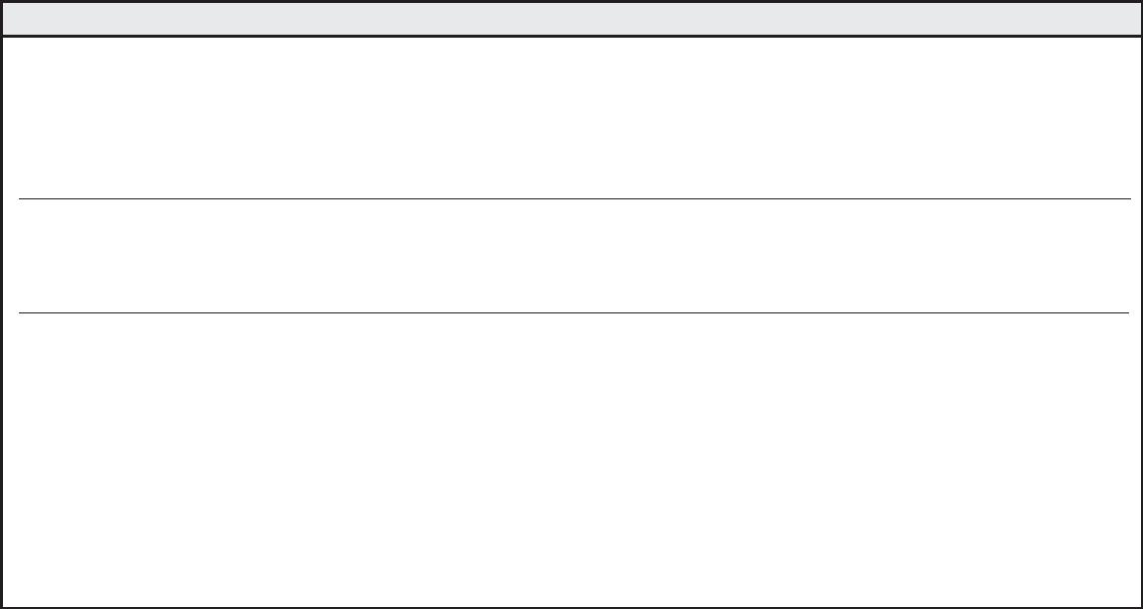
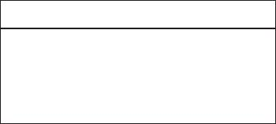






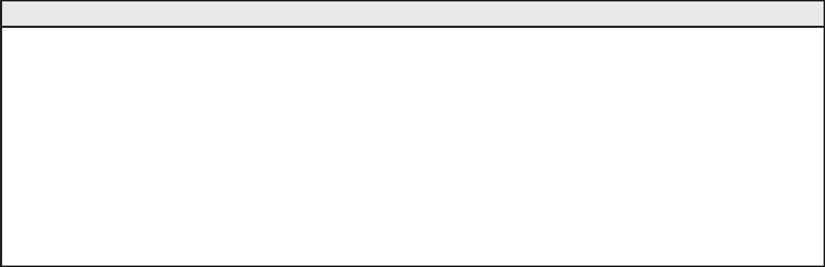
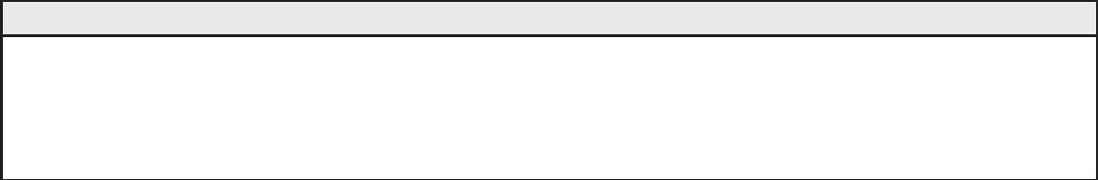
for office Use only
Student ID #: ___________________________
Date Issued: ___________________________
Application #: __________________________
ApplicAtion
for Admission
city University of seattle
11900 NE First Street
Bellevue, WA 98005
U.S.A.
University of international Business & economics
No. 10, Huixin Dongjie,
Chaoyang District,
Beijing, China
pArt A – stUdent informAtion
1. Name: ________________________________________________________________________________________________________
Last (Family) First Middle
2. Mailing address: ________________________________________________________________________________________________________________________________________
Street/P.O. Box
Apt. Number
City
State/Province
Country
Postal Code
3. Permanent address: ____________________________________________________________________________________________________________________________________
Street/P.O. Box
Apt. Number
City
State/Province
Country
Postal Code
4. Gender: q Male q Female
Date of Birth: ___________________ /___________ /______________ (MM/DD/YYYY)
5. City University of Seattle Student ID # (If none, leave blank) __________________________________________________
6. Current TOEFL or ELTS score available? q Yes q No
(If applicant does not meet the English proﬁciency requirement, student will be required to pass the English placement test prior to starting the program.)
7. Check the quarter you wish to begin:
q Fall
q Winter
q Spring
q Summer
Year __________________
8. Program of Study – master of Business Administration in Global management
pArt B – prior edUcAtion
List only colleges or universities that will supply transcripts to City University of Seattle at your request. Oﬃcial transcripts from these colleges or
universities must be sent to City University of Seattle in sealed institutional envelopes. All transcripts must be oﬃcial (original or certiﬁed copies of
original) documents. Translations, if necessary, must be certiﬁed by the U.S. Consulate, Ministry of Education or the institution itself.
College/University
Location
Attendance
(from - to)
Certiﬁcates/Credits
Degrees Received
Date Transcripts
Requested
Check if
Enclosed
______________________________________________________________________________________________________________________________________ q
______________________________________________________________________________________________________________________________________ q
______________________________________________________________________________________________________________________________________ q
______________________________________________________________________________________________________________________________________ q
In which country did you complete high school? _____________________________________________________________________________________________ q
employment/reimBUrsement informAtion
Are you currently employed?
q Yes q No
Employer ________________________________________________________
Does your employer have a reimbursement program?
q Yes q No
q I don’t know
If Yes, name of reimbursement program _____________________________________________________________________________
SP3237
Page 1


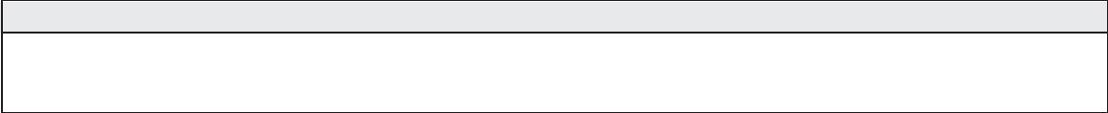
pol ic ies & pr oc edUr es
equal opportunity/non-discrimination Grievance procedure
City University of Seattle subscribes to the principles and laws of individual
states and the federal government, including applicable Executive Orders
that pertain to civil rights, equal opportunity, and aﬃrmative action.
of which the aggrieved party will receive a copy, will be prepared within
10 additional working days for review by the President of the University.
7. When the appropriate action has been determined, all parties
involved will be informed of the decision in writing. Finally, a follow-up
procedure will be developed to ensure the action that was agreed upon
is carried out accordingly.
City University of Seattle prohibits discrimination on the basis of race, gender,
religion, age, national or ethnic origin, physical, mental or sensory disability,
marital status, sexual orientation, and status as a veteran. The policy regulates
the recruitment, employment, and retention of faculty and staﬀ and the
operation of all University programs, scholarships, loans, activities, and services.
Documentation of all proceedings will be held in strictest conﬁdence and
maintained in a conﬁdential ﬁle.
It is the responsibility of all City University of Seattle employees to refer
a student grievance to the Director of Human Resources or appropriate
designee for compliance with this procedure.
City University of Seattle has created the following procedure to provide an
eﬀective and acceptable way to bring to the University’s attention any equal
opportunity/non-discrimination, disciplinary or conduct-related problems
and complaints. The procedure helps identify and eliminate legitimate
causes for dissatisfaction and enables students, faculty and staﬀ to ﬁle a
grievance without fear of retribution or prejudice. The procedure is separate
from and applies to all issues other than grades.
substance Abuse policy
The goal of City University of Seattle’s substance abuse policy is to ensure
that the University and all its locations are free of illegal drug use, alcohol
abuse or illegal drug activity. All City University of Seattle employees, faculty,
staﬀ and students will be provided with a complete copy of this policy.
From time to time, drug-related educational materials and programs will be
oﬀered to enhance your awareness of the facts about alcohol abuse, as well
as illegal drugs and the consequences of their use. Materials and programs
also will describe the alternatives available to you in the event that you
are or may become involved with drugs and feel the need for professional
assistance. The University’s typical response to voluntary requests for
assistance is summarized in the policy. The policy’s legal basis is the Federal
Drug-Free Workplace Act of 1988, and Drug-Free School and Com munities
Act-Higher Education, Drug-Free Schools and Campuses, August 16, 1990.
These laws and this policy apply to all City University of Seattle employees,
faculty, staﬀ and students, full-time, part-time and on-call. City University
of Seattle is required by strict mandate of the Department of Education to
implement and enforce these regulations.
Evidence of practices that are inconsistent with this policy should be
reported to the Human Resources Oﬃce. If a situation warrants further
administrative assistance, after using City University of Seattle’s grievance
procedure and appeals conciliation process, public resources are available
through the U.S. Department of Education, the U.S Oﬃce of Civil Rights, and
the Washington State Human Rights Commission.
t he grievance ﬁling procedures are as follows:
1. The aggrieved party contacts the Director of Human Resources or
appropriate designee as soon as a problem is recognized.
2. The aggrieved party and the Director of Human Resources or
appropriate designee meet where an appropriate form is provided for
the aggrieved party.
3. Once the form is completed, the Director of Human Resources or
appropriate designee conducts an investigation and prepares a report
of ﬁndings.
disclosure of c ampus security policy & c ampus c rime statistics Act
City University of Seattle is a private nonproﬁt institution of higher education.
Its mission to provide educational opportunities world wide, prima rily
to segments of the population not being fully served. City University of
Seattle is committed to the safety and security of its entire faculty, staﬀ and
students. In accordance with the Jeanne Clery Disclosure of Campus Security
Policy and Campus Crime Statistics Act, the university is dedicated to the
accurate and timely dissemination of all crime statistics and security related
information to our constitu ents. The annual report containing campus
and non-campus crime statistics and related information may be accessed
at www.cityu.edu. Paper copies are available upon request by calling our
Human Re source Department at 1.800.426.5596, extension 7613.
4. The Director of Human Resources or appropriate designee reviews
the ﬁndings with the aggrieved party’s department head and the
University’s management team.
5. Within 10 days the outcome of these reviews will be shared with the
aggrieved party.
6. In the event of any apparently irreconcilable conﬂict, a three-person
board comprised of non-involved management, supervisory staﬀ and a
member of one’s peer group will be appointed to review the grievance
and attempt conciliation. The board’s written recommendation,
eq UAl oppor t Un it y, dr UG An d Gr iev An c e pol ic ies
By signing this form I conﬁrm that have read and understand the above equal opportunity, drug, grievance, and campus security policy statements.
please initial and date _________________________________________
s pec iAl Ac c ommodAt ion s
Do you require special accommodation? q Yes q No If yes, please contact the Disability Resource Oﬃce at 800.426.5596 ext. 7620
I hereby certify that the information I have provided on this application is accurate and complete to the best of my knowl edge. I acknowledge that the
falsiﬁcation of information of information on the application or other required documents will result in the dismissal from the university.
q I hereby authorize City University of Seattle to release my information about my records to: University of international Business & economics
Student Name (please print) _______________________________________________________________________________________
Student Signature ___________________________________________________________________ Date _______________________
How did you hear about us?
q Family/Friends q Student Fair q Internet q Publication q Other__________________
SP3237
Page 2

